Lesson 3 Homework | LT 4.2 and 4.3 | 3-7odd, 9-11, 13, 14, 20, 21, 25, 27, 35, 37, 38 (draw a picture & make markings for all problems)

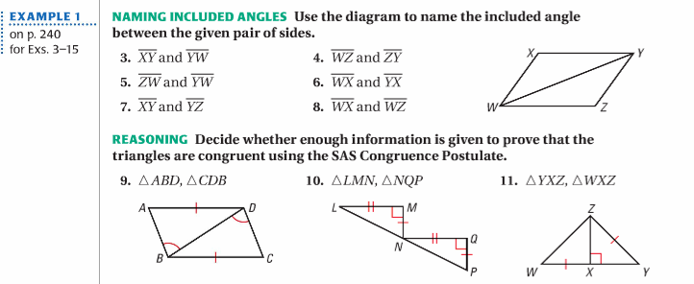

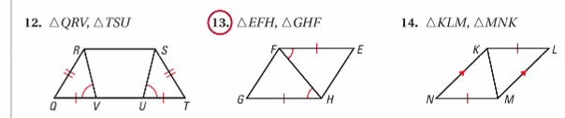

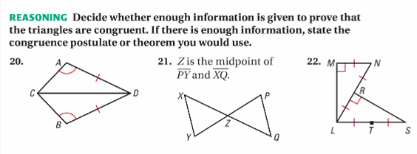

Lesson 3 Homework | LT 4.2 and 4.3 | 3-7odd, 9-11, 13, 14, 20, 21, 25, 27, 35, 37, 38 (draw a picture & make markings for all problems)

